**Music like a river**

**似水流音**

（英文部分选自经济学人20160430期讣告）

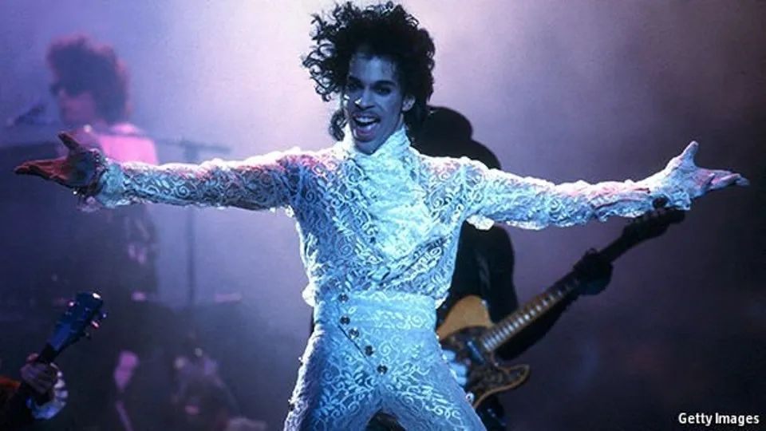

Prince

王子

**Musique like a river**

**似水流音**

**Prince Rogers Nelson, musician, died on April 21st, aged 57**

**音乐家普林斯·罗杰斯·纳尔逊，又名“王子”，于2016年4月21日逝世，终年57岁【也可以说“享年”】**

So sexy, freedom. So sexy, **he couldn’t begin to explain it**. Free to put on mascara, paint his lips, **glue on** long eyelashes to lower, flutter and seduce. Wear any colour, especially purple, but also electric blue, scarlet, glitter-silver and eye-aching lizard green. **Strut** in ruffles, squeeze in black leather, preen his naked midriff, shake his nakedass out of a yellow jumpsuit. Stack his heels, until his elfin figure became a giant. Dance with a white man, writhe with a black woman, kiss both, **couple with** either, be both races and sexes and neither in one cat-like, commanding frame. And, along the way, sell more than 100m records worldwide.

自由是如此性感，性感得**令他难以言状**。他自由地涂上睫毛膏，描画嘴唇，粘上长睫毛，低眉、眨眼、引诱。他服装五颜六色，尤爱紫色，但也喜欢铁蓝、猩红、亮银和刺眼的蜥蜴绿。他穿着带褶边的衣服**昂首阔步**，挤进紧身的黑皮衣，精心修饰裸露的上腹部，身着黄色连衫裤摇晃着裸露的臀部。他脚踩恨天高，小巧的身形看起来高大无比。他和白人男性跳舞，与黑人女性一起摇摆，和他们亲吻，和他们交合。他是不同肤色和性别的结合体，但是他那猫一样威严的身形又不受肤色和性别的限制。一路走来，他在全世界卖出了1亿多张唱片。

Free in his music, too. **Brutal as a rapper, tender as a balladeer**, **swooping smoothly from bass to falsetto**. Astounding on guitar, **soaring off** into a universe of riffs and improvisations. At the half-time concert at the Super Bowl at Miami in 2007, in torrential rain, he seemed unable to stop; and it was the same on piano, keyboards, percussion, drums. He played 27 instruments on his first album, “For You”, in 1978, but felt he had the hang of thousands.

音乐里的他也是如此自由。**既能像说唱乐手一样冷酷无情，也能像民谣歌手一样柔情似水**，**可以在低音和假声之间转换自如**。他的吉他演奏能迅速上升到重复段和即兴演奏，令人惊叹。2007年在迈阿密超级碗的中场秀上，尽管大雨倾盆，但他似乎无法停止表演。他对钢琴、键盘式乐器、打击乐器和鼓也是得心应手。他在1978年发行的第一张专辑《为你》中演奏了27种乐器，但是他自认为通晓数千种乐器。

A thousand genres, too, from funk (“Kiss”), dance (“Uptown”), rock (“The Cross”), techno (“New World”), pop (“When Doves Cry”), obscenity (“Jack U Off”), beauty (“Nothing Compares 2 U”) and all the world in between. Half a dozen genres in the same song, sometimes. The rhythm & blues of Little Richard, the soul of Sly Stone, the clicks and whoops of Michael Jackson, James Brown, Miles Davis, Marvin Gaye, Duke Ellington, were **mixed up**, fused, made fantastic, and **poured in** astonishing profusion through his guitar. **If he couldn’t get the music out of his head, everyone’s music as well as his, he couldn’t function.**

他擅长的音乐风格同样数不胜数，跨度极大，从放克（《吻》）、舞曲（《上城》）、摇滚（《十字架》）、科技舞曲（《新世界》）、流行乐（《当鸽子哭泣》）到低俗音乐（《解脱》）和优雅音乐（《无与伦比》）。有时同一首歌里融合六七种音乐风格。小理查德的节奏布鲁斯（R&B）、史莱·史东的灵魂摇滚乐、迈克尔·杰克逊的吸气声和尖叫，以及詹姆斯·布朗、迈尔斯·戴维斯、马文·盖伊、艾灵顿公爵等歌手的表演风格，经他混杂、融合，形成绝妙的音乐，随着他的吉他演奏**倾泻而出**。**他脑海里充斥着各种各样的音乐——他自己的，也有别人的——如果不把这些音乐从脑海里释放出来，他将寝食难安**。

注释：

Techno： 科技舞曲是利用电脑，合成器合成,做出一些特殊音效,这种音乐常常是许多音效组合起来的。科技舞曲从80年代中期的底特律开始走向世界，它由不停反复的旋律和节奏构成，给人的感觉就像反复涌动的机械声浪，带有几分忧伤和冷漠的气息。

**Most necessary of all was the freedom to *reinvent* who he was**, **throw the world off his track, and hide**. In the mid-1980s he refused to give interviews, **reducing any to the statement**: “I’m looking for the ladder.” When writing songs for other people he hid behind the names “Jamie Starr” and “Alexander Nevermind”. **In the wake of** his album “Purple Rain” (1984), which sold more than 20m copies, became a film and won him an Academy Award for best score, **he made a cult of that colour, like a cloak.** The best ruse came in 1993 when he changed his name to an unpronounceable symbol that combined, gracefully, the male and female signs. It couldn’t even be whispered; he drew it on the air. If people called him Prince, he didn’t know who they were referring to. His name was right there, beautifully enciphered: all he was, and all his music was about.

**当然，对他而言最为重要的是自由地*重塑*自己，置身世外，遗世独立**。80年代中期，他拒绝采访，**只给出一句**：“我正在找梯子。”在为他人写歌时，他使用化名“杰米·斯塔尔”和“亚历山大·无所谓”。1984年发布的专辑《紫雨》销量超过两千万，被拍成电影，并获得奥斯卡最佳原声歌曲奖。专辑一经发布，**他便掀起了对于紫色的狂热崇拜，就像是他的伪装**。1993年，他十分巧妙地将自己的名字改成一个无法发音的符号，优雅地融合了代表男性和女性的两个标志符。这个名字很难念；他却让世人熟知。如果别人叫他王子，他不会作出回应。他的名字就在那儿，那个美丽而神秘的符号代表了他的全部，以及他的音乐。

**There was also a sharp point behind it**. He was fighting his recording company, Warner Bros, because they weren’t releasing his albums fast enough to keep up with the music inside him. He was defying them because the name “Prince” was now their property, not his. Not even the rights to his own songs belonged to him. He wasn’t going to be yet another black entertainer selling his soul, as Little Richard had, for a new car and a bucket of chicken. He’d got a pink Cadillac thanks to Warner Bros; that was enough. At the Brit Awards in 1995 his 13 words of thanks concluded: “In concert: Perfectly free. On record: Slave.” “SLAVE” was written on his face too, in bold black pen. After 19 years he wrestled free, putting out an album called “Emancipation” and answering to Prince again. He **made a stand for** all black musicians, not just himself.

**改名背后还有一个尖锐的问题**。当时，他正与他的唱片公司华纳兄弟斗得不可开交，因为公司给他出专辑的速度太慢，跟不上他创作的脚步。他向公司表示反抗，因为“王子”这个名字当时已属于公司财产，而不归他个人所有。就连他自己创作的歌曲，在法律上也不属于他自己。黑人明星小理查德为了新车和炸鸡桶出卖自己灵魂，他绝不会步人后尘。华纳兄弟公司确实给了他一辆粉色的凯迪拉克，那这就够了罢。1995年，他在全英音乐奖上的获奖感言非常简练：“于音乐会：无限自由。于唱片：只是奴隶。”他曾将“奴隶”一词用加粗的黑色笔写在脸上。历经19年的缠斗，他终获自由，并发布专辑《解放》，再次用回“王子”这个名字。不光是为自己，他为所有黑人音乐家争了一口气。

Uncatchable

捉摸不定

Could anything **pin him down**? Not women: **his two marriages were unhappy, and didn’t last**. Not time: his sense of it was limited to an indefinite future, his appearances onstage usually late. Not expectations, because he could cancel shows on a whim and then as suddenly **put them on**, impromptu, all-night and free. Not religion, because his fervour as a fresh-minted vegan, teetotal Jehovah’s Witness came and went, together with the spirits who sometimes **ordered him around**.

有任何东西可以**束缚**他么？不是女人：**他的两段婚姻都不幸福，亦未善终**。不是时间：他对时间的感知仅限于无限的未来里，他的登台亮相经常迟到。不是期望：他可以一时冲动取消表演，然后又改变主意，即兴表演，整晚地自由放任。不是宗教：时而是素食主义者和滴酒不沾的耶和华信徒，时而又酒肉穿肠过，还有各种他臆想在他脑子里作祟的各种神仙妖怪。

**Roots *defined* him slightly**. He was born and schooled in Minnesota and stayed loyal to it, supporting the Timberwolves, **sneaking into** the Dakota Jazz Club in Minneapolisand building his studio complex at Paisley Park in Chanhassen. There, though, **he was as elusive as ever**, **not to be caught on any recording device**, including mobile phones. Fleeting impressions only, like vivid strobes. The internet bothered him, and he **strove to** ban his music from Spotify, iTunes and anywhere where he could not control it. For a while he tried to ban his showman’s likeness, too.

**故土悄无声息地*塑造*着他**。他出生在明尼苏达州，在那里接受教育，并一直忠诚于它，他支持森林狼队，偷偷溜进明尼阿波利斯的达科他爵士俱乐部，还在昌哈森的佩斯利公园建造了自己的工作室。然而，在那里，**他还是和往常一样让人难以捉摸**，**没有关于他的任何的影像记录**，包括手机影像记录都没有。仅有的印象也像生动的闪光灯一样转瞬即逝。互联网困扰着他，他想方设法禁止他的音乐作品入驻Spotify、iTunes和任何他无法控制的地方。有一段时间，他甚至试图禁止任何媒体使用他的肖像。

**Only one thing held him**. He felt its tingling grip when he was seven, struggling to be good enough to be allowed to play his father’s piano. **It possessed him at Minneapolis Central High School**: all those hours in the music room, his already-high-teased hair **nodding over** the keys, after his friends had gone home. **It roared through his body on the stage like a river without end**. At Paisley Park, if he was not at his purple grand piano, he would be recording; and though he produced 39 studio albums, four in his last 19 months alone, he still had shelves of recordings that were not quite ready, not sufficiently perfect, in his vault: enough material (some said) to make annual albums for the next hundred years.

**只有一件事能让他魂牵梦绕**。七岁时，他感觉到了它强烈的控制，只有努力让自己变得足够好，才能获允弹奏父亲的钢琴。**在明尼阿波利斯中央高中时，这种感觉吞噬了他**：朋友们回家之后，他把所有的时间都奉献给了音乐室，高高梳起的头发随着手指在琴键上肆意跳跃。**在舞台上，它呼啸着穿透他的身体，就像一条奔腾不息的河流**。在佩斯利公园的工作室里，如果他不在紫色三角钢琴前，那么他就是在录音；尽管他制作了39张录音室专辑，仅仅是生命最后的19个月中就制作完成了四张，但其实他的保险库中仍有成架尚未准备好、不够完美的唱片：（据说）这些素材用来制作接下来100年的年度专辑都绰绰有余。

To **be bound to** music was sexier even than freedom. **So he let it fill both his days and his white, unsleeping nights**.

被音乐束缚甚至比自由更性感。所以他用音乐填满了他的白天和不眠之夜。